**Assignment 2**

**INSTRUCTION :**

### For each exercise refer to the Verilog Codes in three methods (dataflow, behavior, and gate level), write the testbench to simulate this module in EDAPLAYGROUND online simulation software, Capture the simulation output text and digital signal waveform to show the results for your homework evidences.

### EXERCISE 1 : WRITE HDL CODE TO REALIZE ALL LOGIC GATES

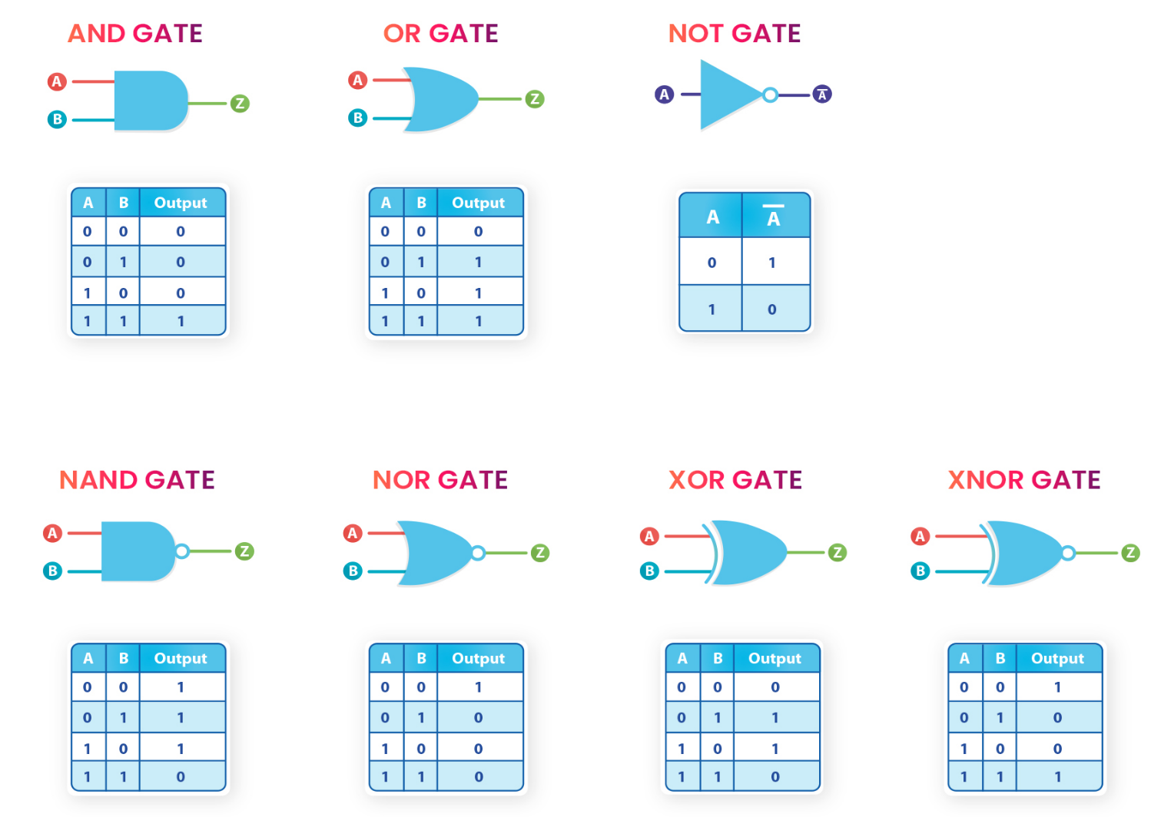

Dataflow model:

module allgate_DF ( a, b, yand,yor,ynot,ynand,ynor,yxor,yxnor );

input a,b;

output yand, yor, ynot, ynand, ynor, yxor, yxnor;

assign yand = a & b; // AND Operation

assign yor = a | b; // OR Operation

assign ynot = ~a ; // NOT Operation

assign ynand = ~(a & b); // NAND Operation

assign ynor = ~(a | b); //NOR Operation

assign yxor = a ^ b; //XOR Operation

assign yxnor =~(a^b); //XNOR Operation

endmodule // END of the module

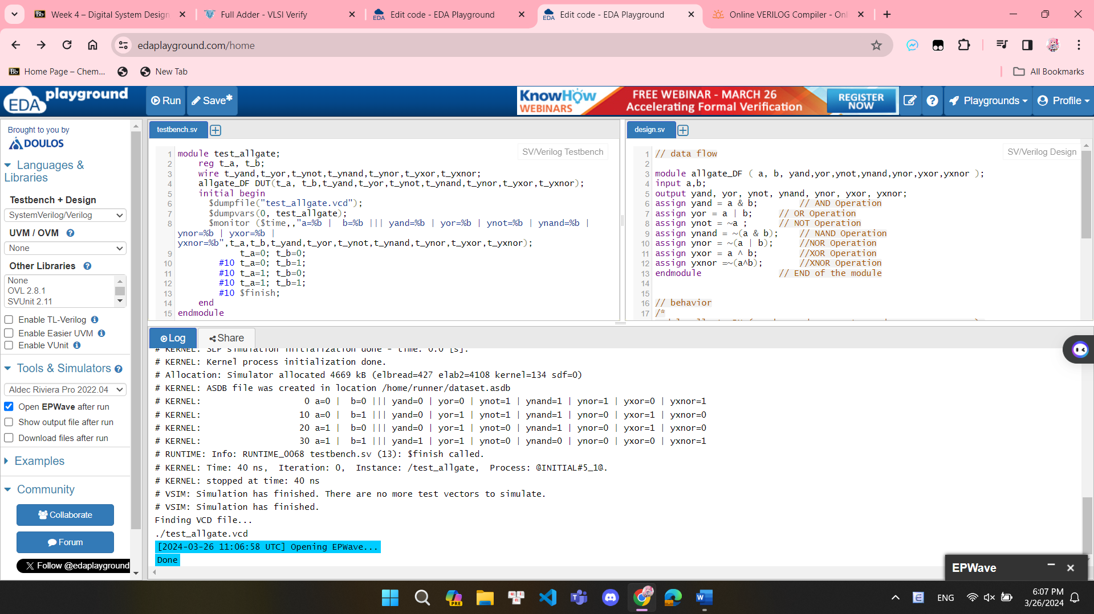  
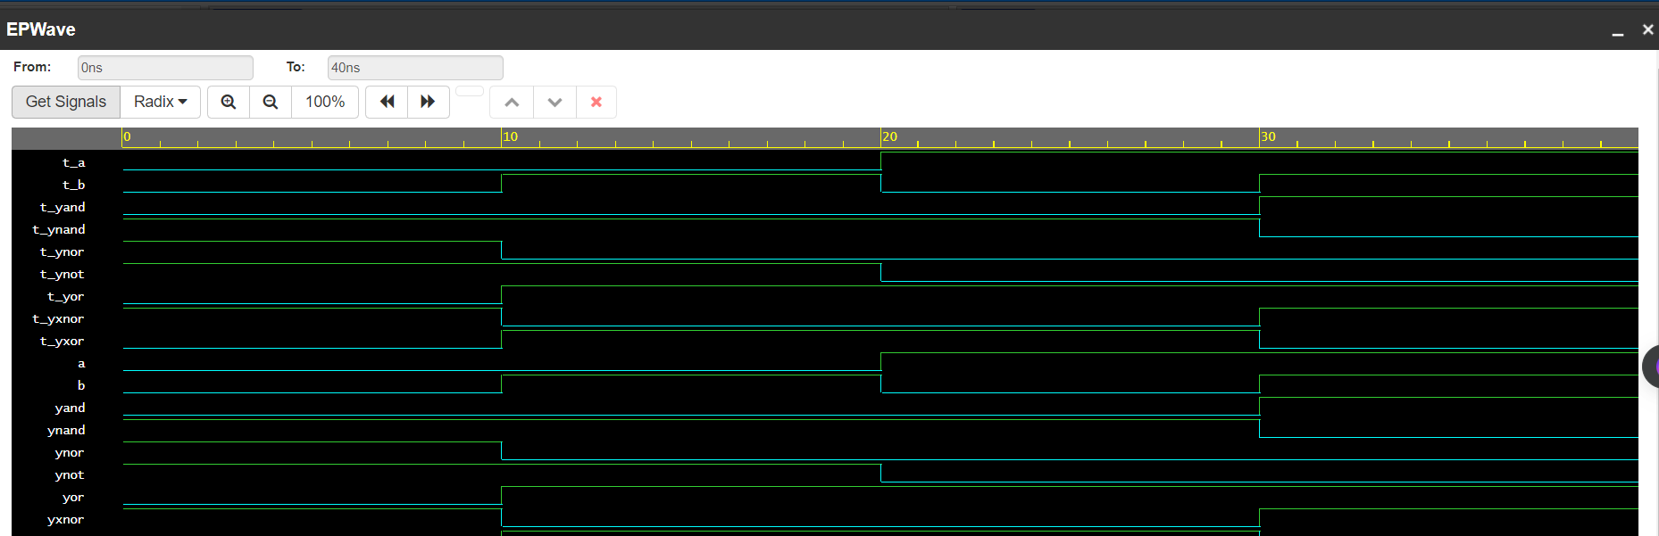

Behavior Model :

module allgate_BH ( a, b, yand,yor,ynot,ynand,ynor,yxor,yxnor );

input a,b;

output yand, yor, ynot, ynand, ynor, yxor, yxnor;

reg yand, yor, ynot, ynand, ynor, yxor, yxnor;

always @(*)

begin

assign yand = a & b; // AND Operation

assign yor = a | b; // OR Operation

assign ynot = ~a ; // NOT Operation

assign ynand = ~(a & b); // NAND Operation

assign ynor = ~(a | b); //NOR Operation

assign yxor = a ^ b; //XOR Operation

assign yxnor =~(a^b); //XNOR Operation

end

endmodule // END of the module

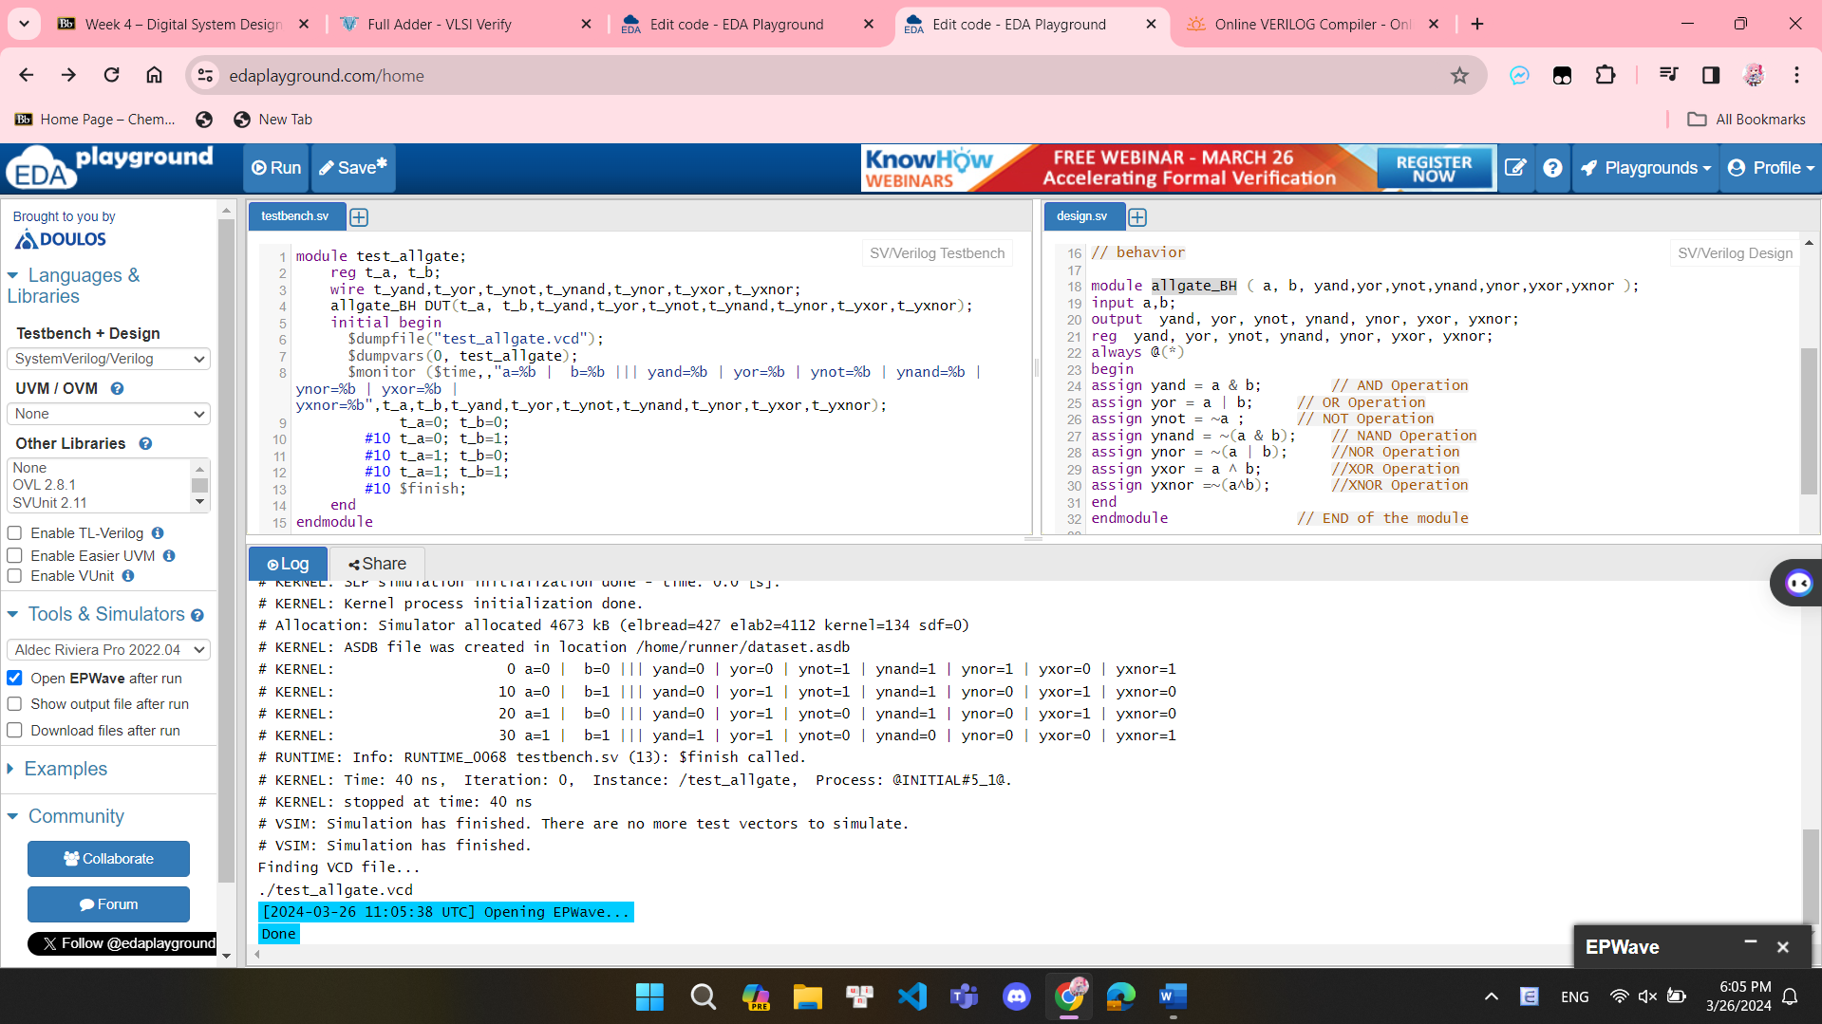

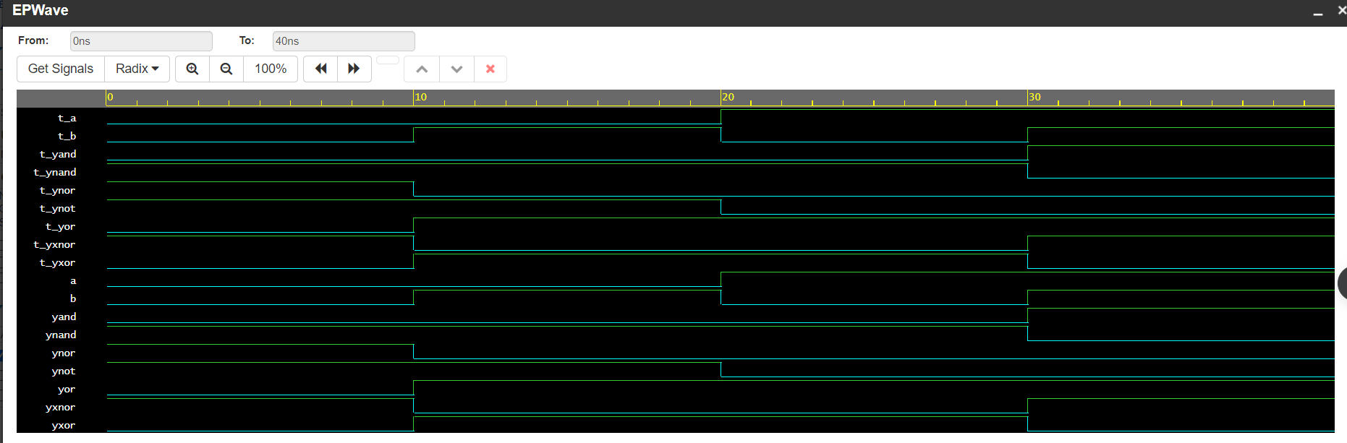

Gate-level (Structural Model) :

module allgate_GL ( a, b, yand,yor,ynot,ynand,ynor,yxor,yxnor );

input a,b;

output yand, yor, ynot, ynand, ynor, yxor, yxnor;

and G1(yand,a,b); // AND Operation

or G2(yor,a, b); // OR Operation

not G3(ynot,a) ; // NOT Operation

nand G4 (ynand,a,b); // NAND Operation

nor G5(ynor,a,b); //NOR Operation

xor G6(yxor,a,b); //XOR Operation

xnor G7(yxnor,a,b); //XNOR Operation

endmodule // END of the module  
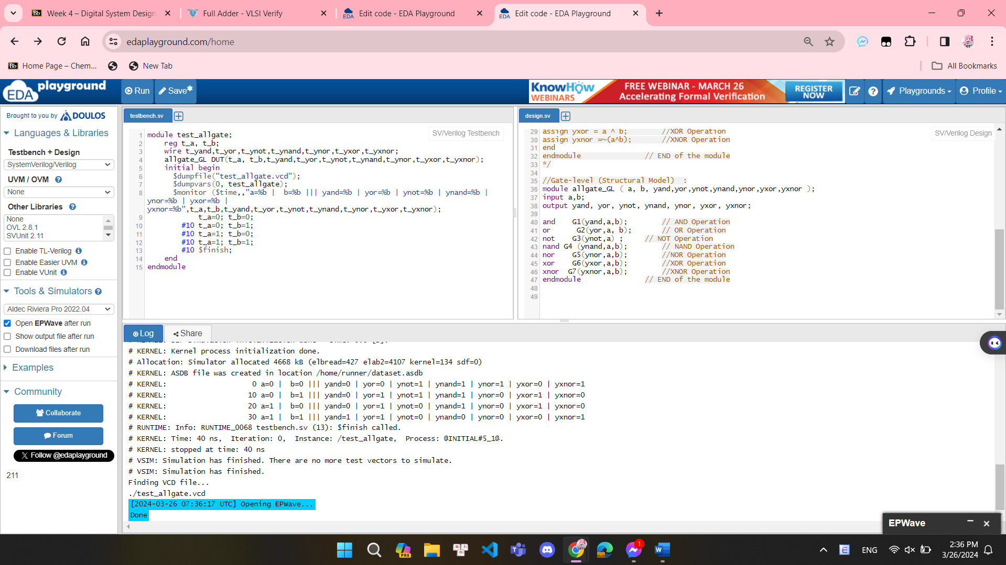

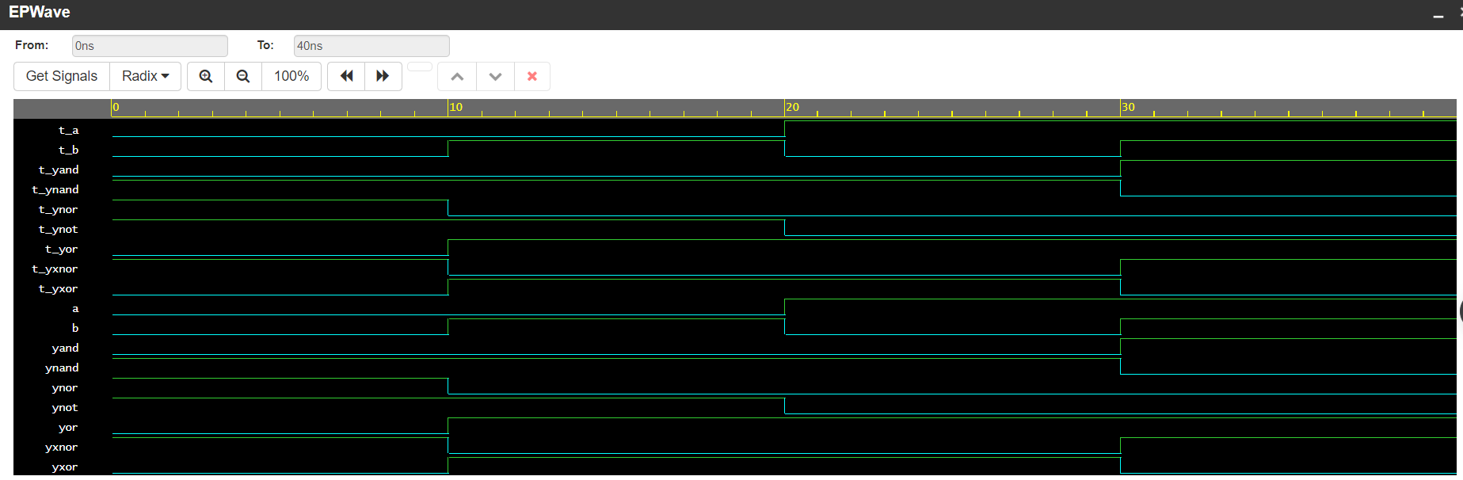

**EXERCISE 2 : WRITE VERILOG TESTBENCH CODES TO SIMULATE THE HALF ADDER CIRCUIT:**

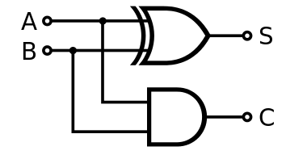 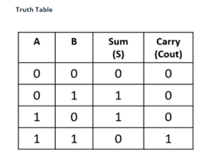

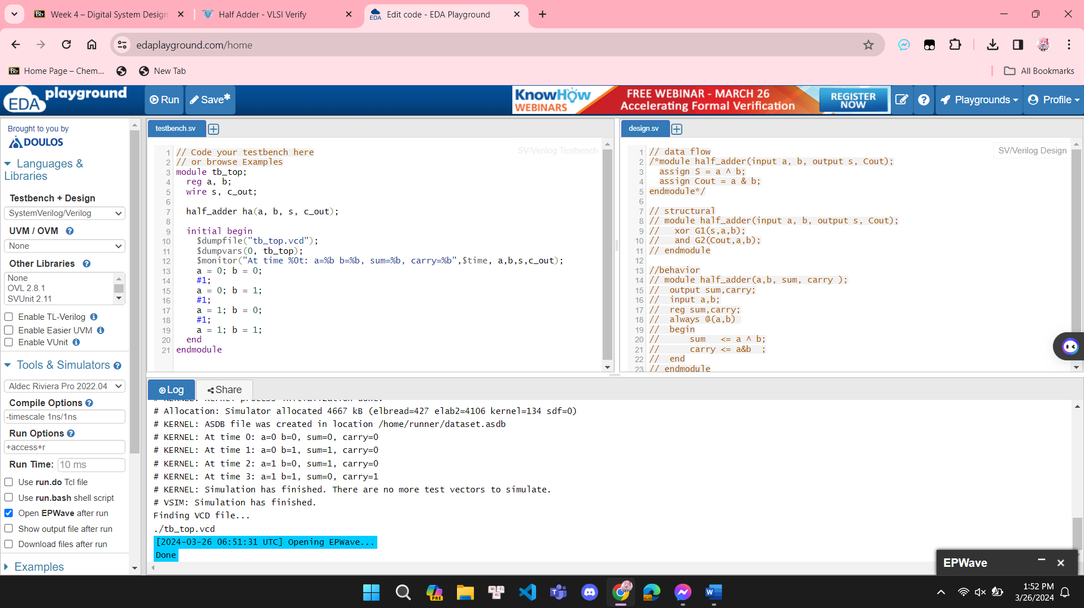

Dataflow model:

module half_adder_dataflow(input a, b, output s, Cout);

assign s = a ^ b;

assign Cout = a & b;

endmodule  
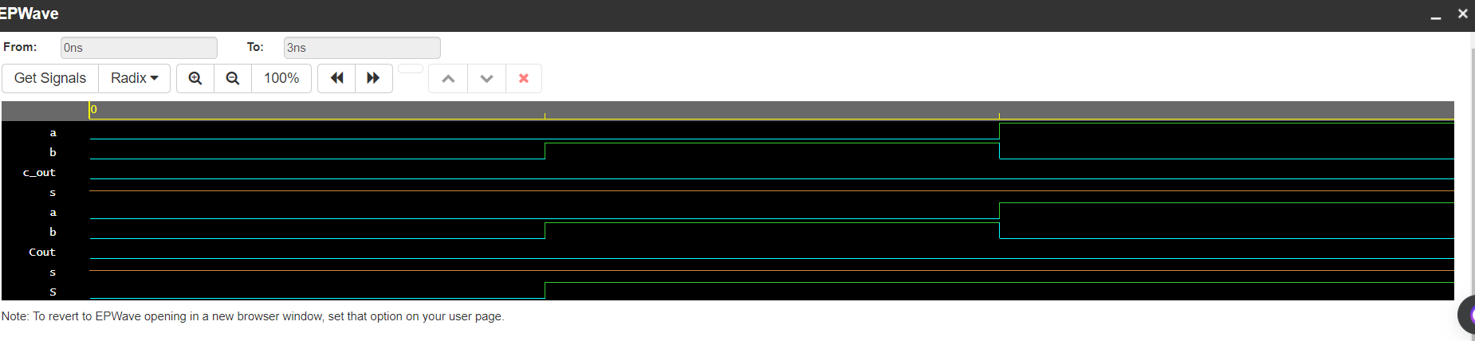

Behavior Model :

module half_adder_behavior(sum,carry,a,b );

output sum,carry;

input a,b;

reg sum,carry;

always @(a,b)

begin

sum <= a ^ b;

carry <= a&b ;

end

endmodule  
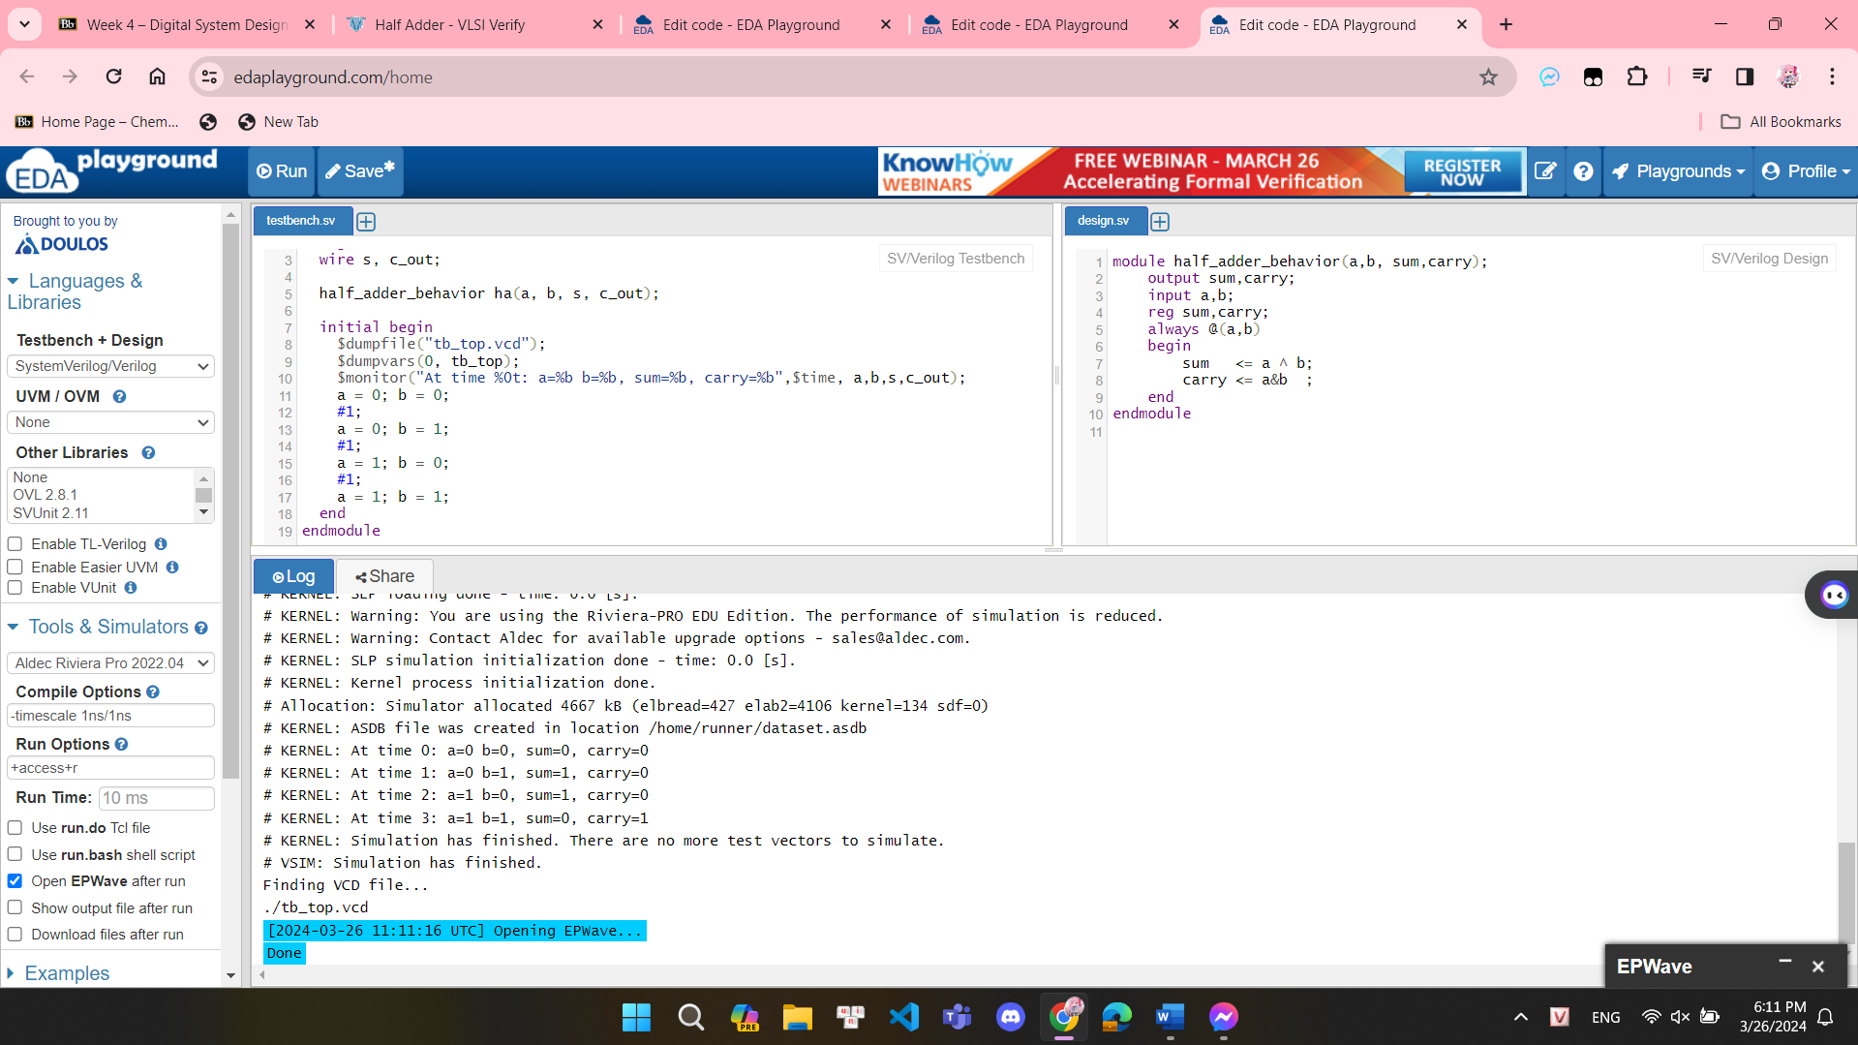  
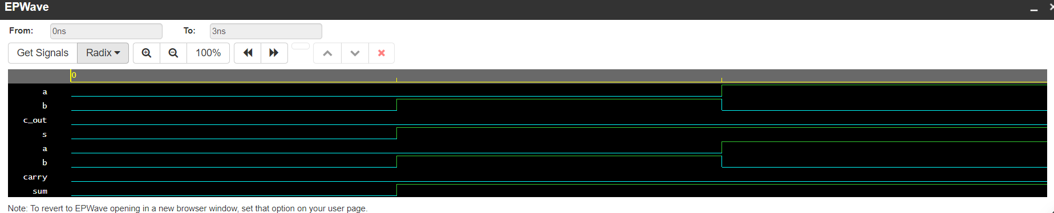

Gate-level (Structural Model) :

module half_adder_structeral(input a, b, output s, Cout);

xor G1(s,a,b);

and G2(Cout,a,b);

endmodule

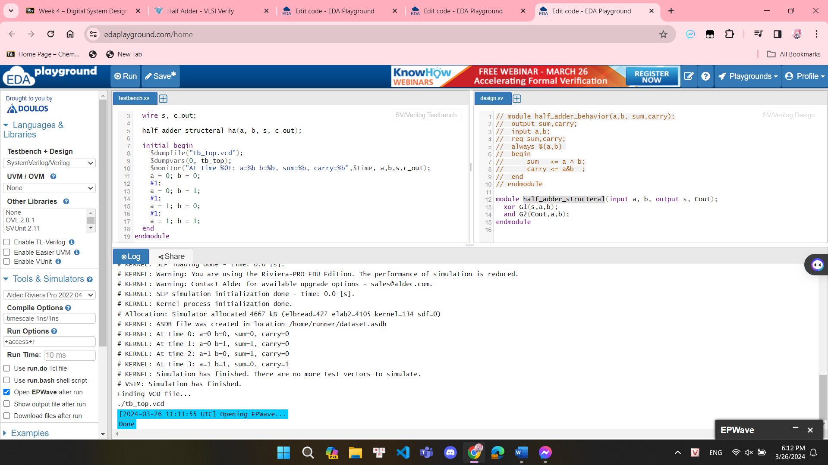  
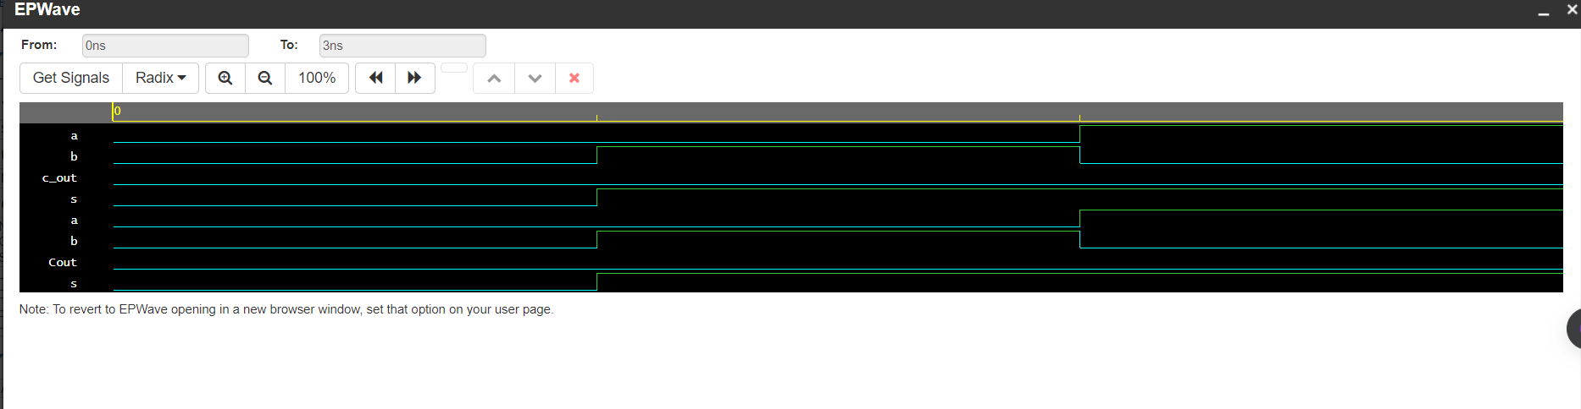

**EXERCISE 3: WRITE VERILOG TESTBENCH CODES TO SIMULATE THE FULL ADDER CIRCUIT:**

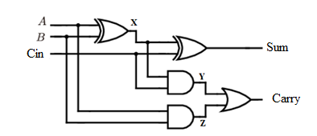 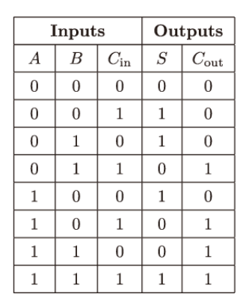

Dataflow model:

module full_adder_DF(input a, b, cin, output S, Cout);

assign S = a ^ b ^ cin;

assign Cout = (a & b) | (b & cin) | (a & cin);

endmodule  
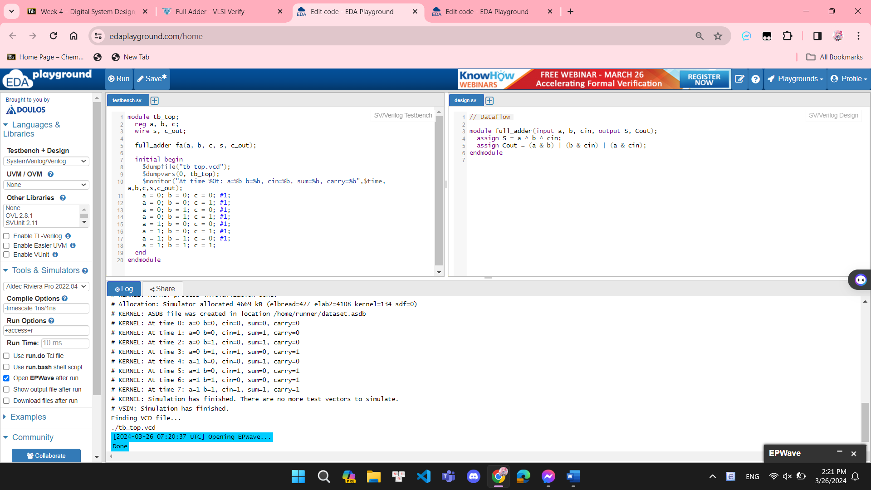  
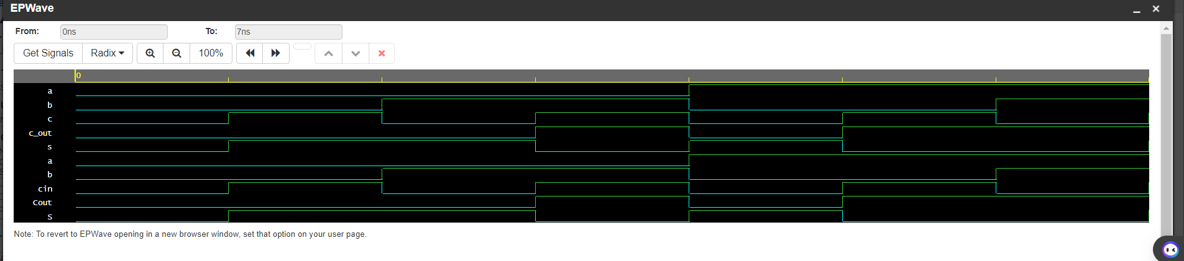

Behavior Model using case :

full_adder_BH1 (input wire A, B, Cin, output reg S, output reg Cout);

always @(A or B or Cin)

begin

case (A | B | Cin)

3'b000: begin S = 0; Cout = 0; end

3'b001: begin S = 1; Cout = 0; end

3'b010: begin S = 1; Cout = 0; end

3'b011: begin S = 0; Cout = 1; end

3'b100: begin S = 1; Cout = 0; end

3'b101: begin S = 0; Cout = 1; end

3'b110: begin S = 0; Cout = 1; end

3'b111: begin S = 1; Cout = 1; end

endcase

end

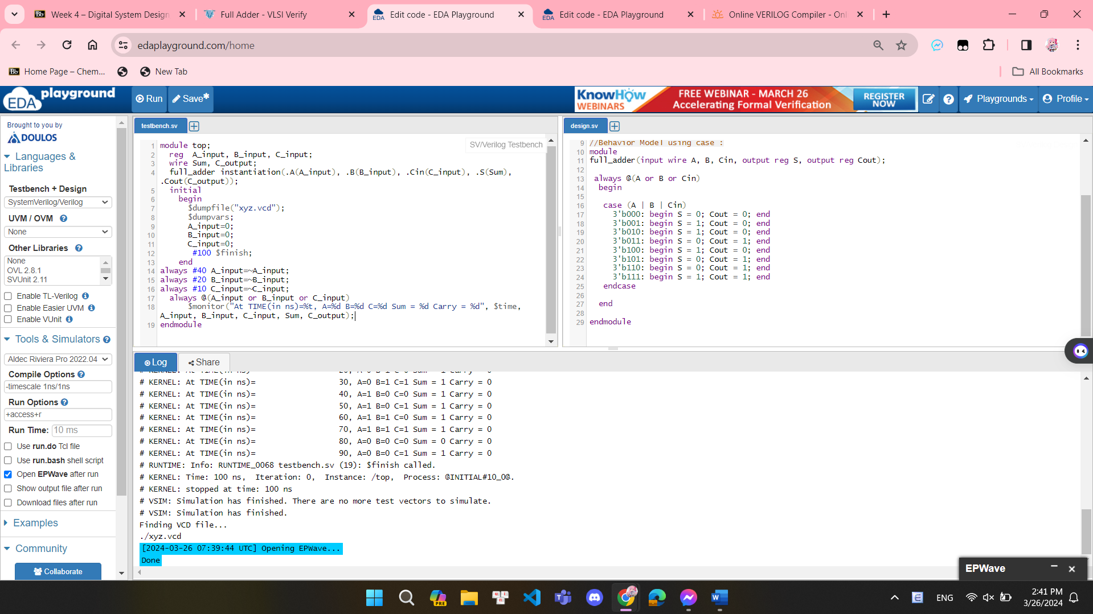  
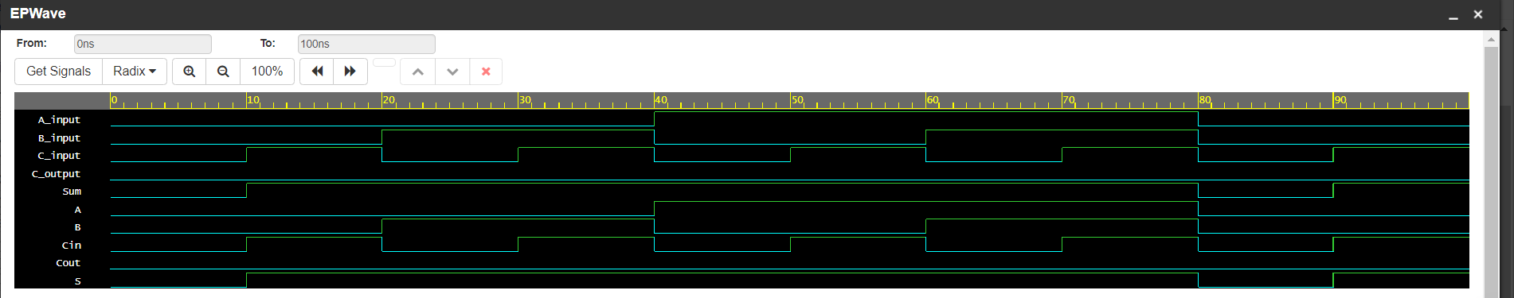

Behavior Model using if else :

module full_adder( A, B, Cin, S, Cout);

input wire A, B, Cin;

output reg S, Cout;

always @(A or B or Cin)

begin

if(A==0 && B==0 && Cin==0)

begin

S=0;

Cout=0;

end

else if(A==0 && B==0 && Cin==1)

begin

S=1;

Cout=0;

end

else if(A==0 && B==1 && Cin==0)

begin

S=1;

Cout=0;

end

else if(A==0 && B==1 && Cin==1)

begin

S=0;

Cout=1;

end

else if(A==1 && B==0 && Cin==0)

begin

S=1;

Cout=0;

end

else if(A==1 && B==0 && Cin==1)

begin

S=0;

Cout=1;

end

else if(A==1 && B==1 && Cin==0)

begin

S=0;

Cout=1;

end

else if(A==1 && B==1 && Cin==1)

begin

S=1;

Cout=1;

end

end

endmodule  
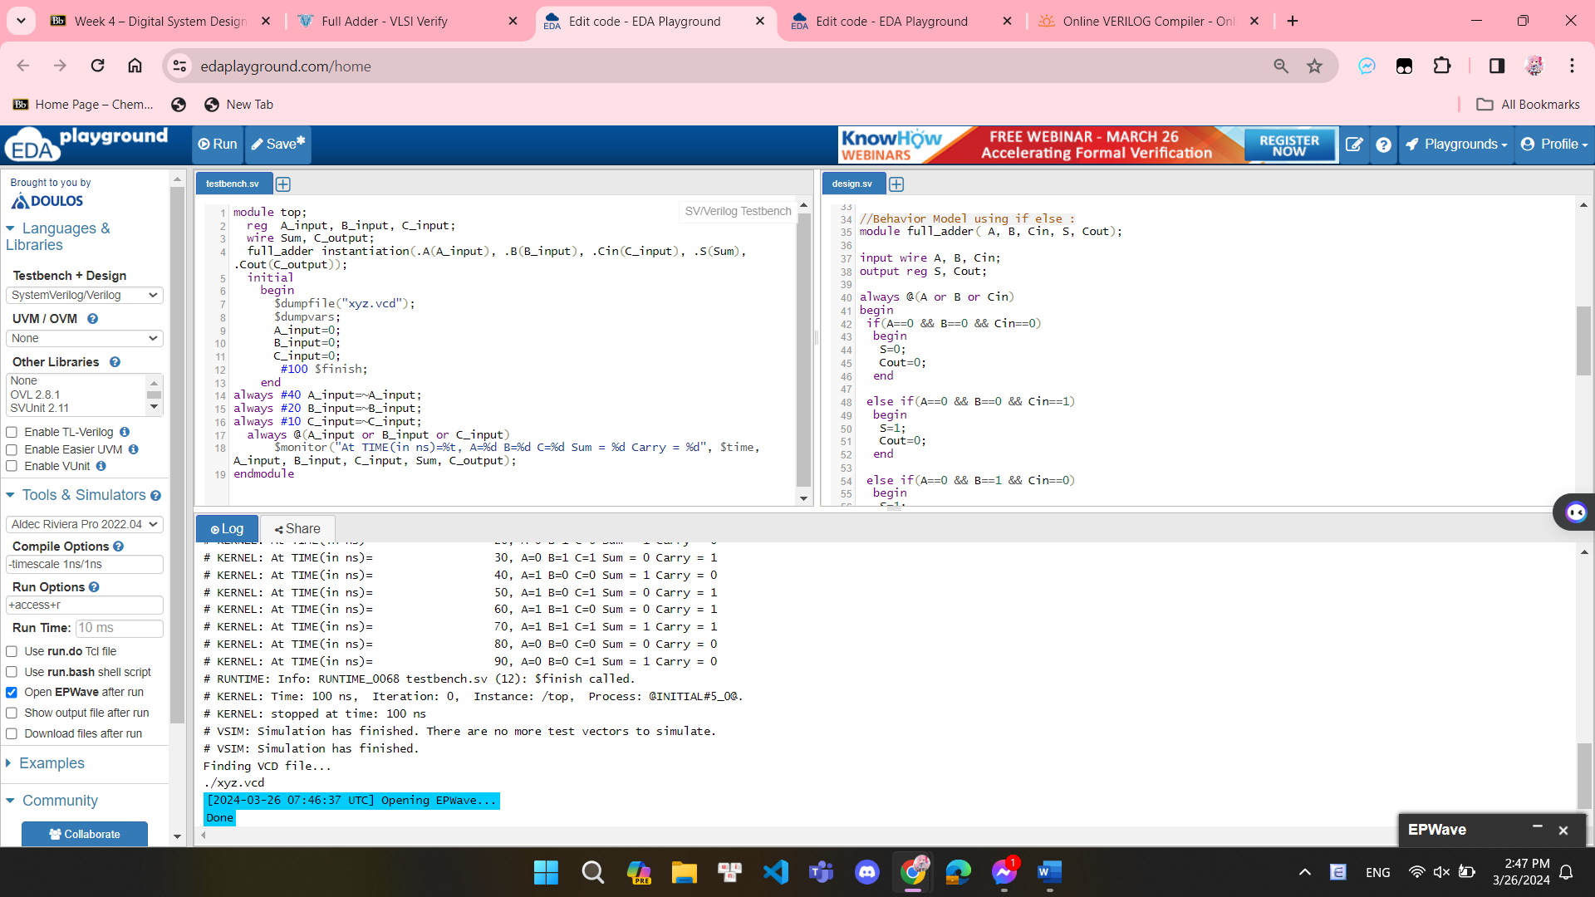

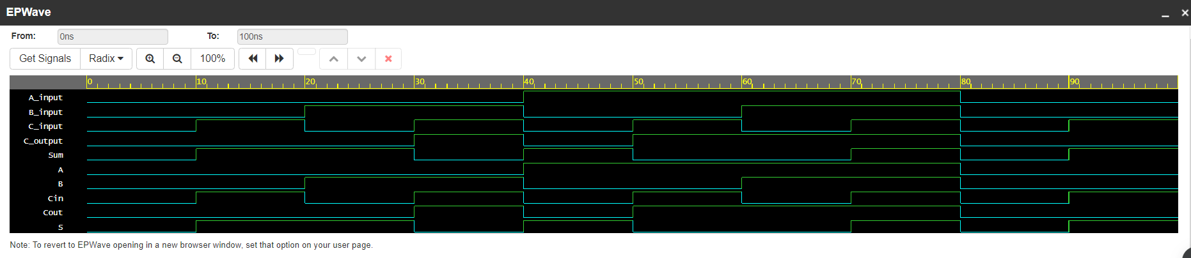

endmodule

module full_adder_BH(a,b,c,sum,carry);

output sum,carry;

input a,b,c;

reg sum,carry;

always @ (a,b,c)

begin

sum <= a^ b^c;

carry <=(a&b) | (b&c) | (c&a);

end

endmodule  
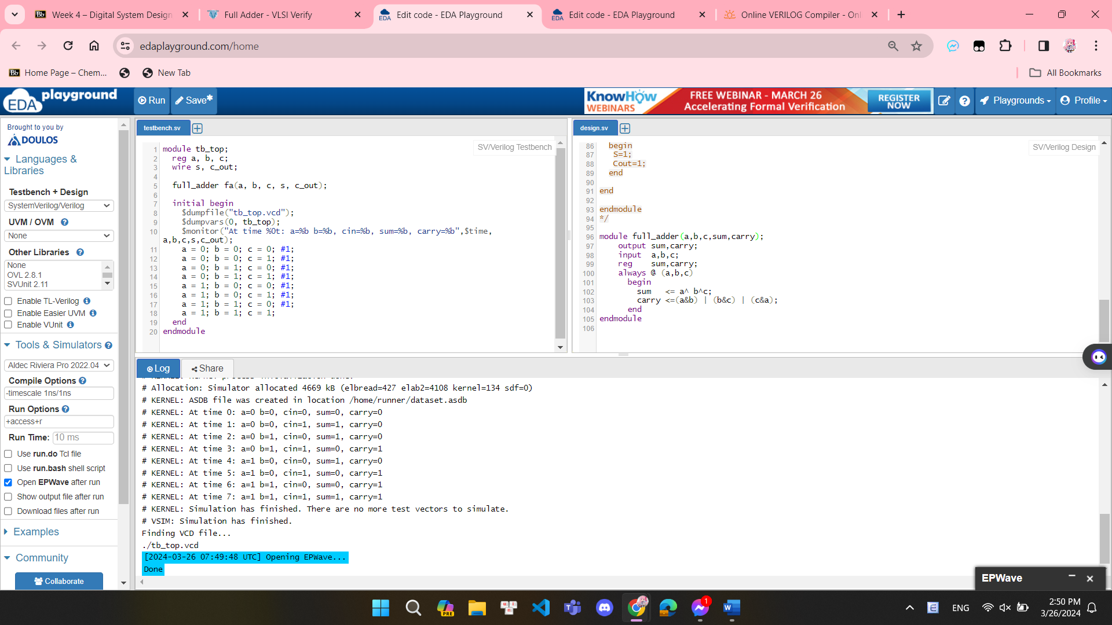

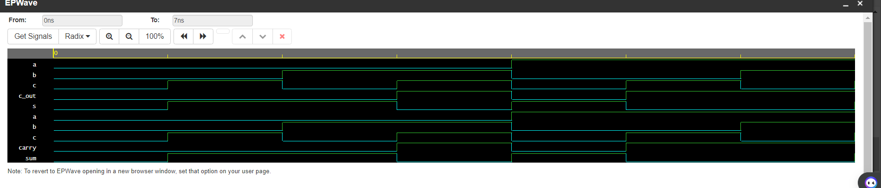

Gate-level (Structural Model) :

module full_adder_STRU(a,b,cin,Cum,Carry);

output Sum,Carry;

input A,B,Cin;

wire x,y,z;

xor g1(x,A,B);

xor g2(Sum,x,Cin);

and g3(y,x,Cin);

and g4(z,A,B);

or g5(Carry,x,y);

endmodule

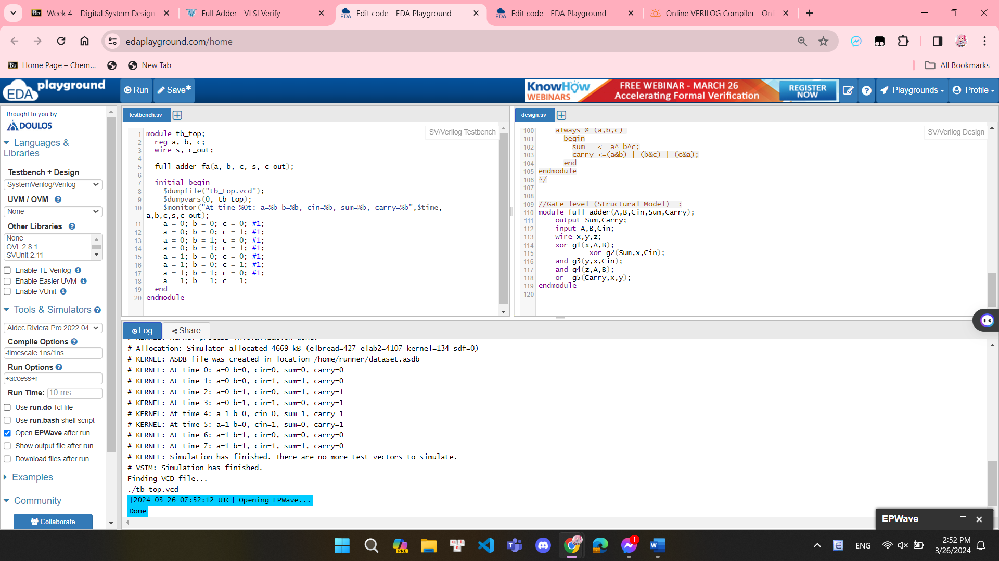

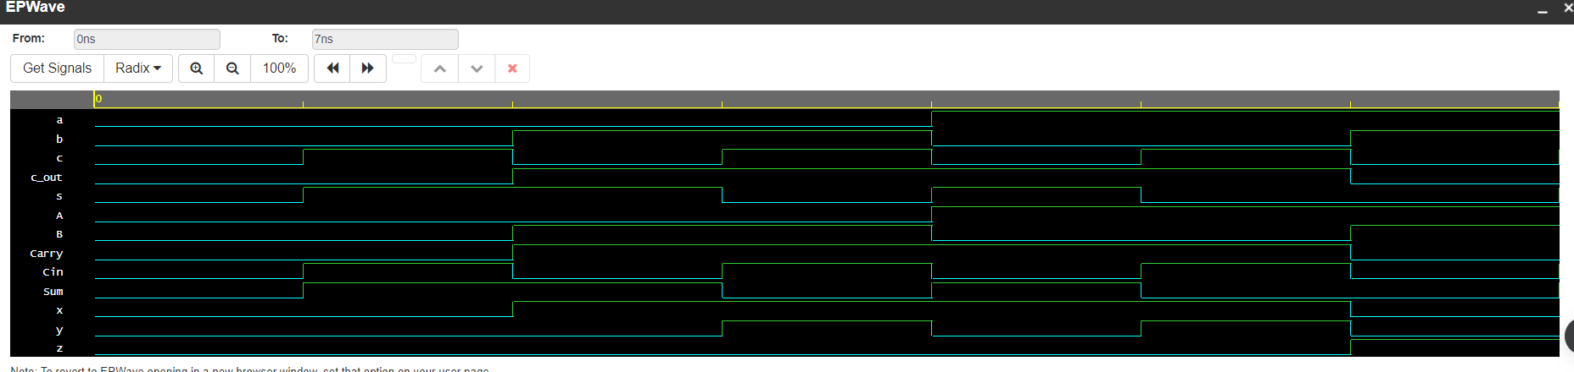

**EXERCISE 4: WRITE VERILOG HDL CODES TO SIMULATE THE RIPPLE CARRY ADDER CIRCUIT:**

****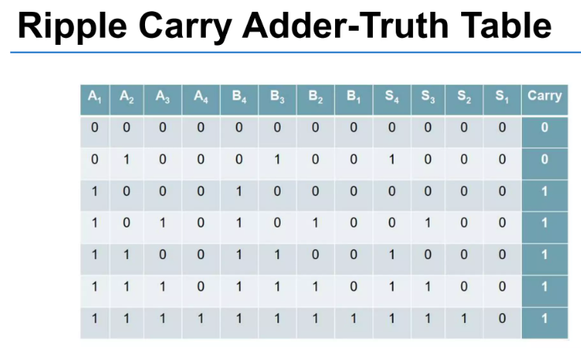

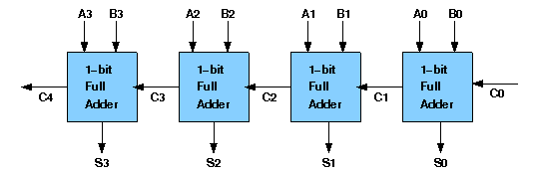

Structural Model:

module full_adder_STRU(a,b,cin,Cum,Carry);

output Sum,Carry;

input A,B,Cin;

wire x,y,z;

xor g1(x,A,B);

xor g2(Sum,x,Cin);

and g3(y,x,Cin);

and g4(z,A,B);

or g5(Carry,x,y);

endmodule

module four_bit_adder_STRU(cin,a,b,s,cout);

input [3:0] a,b;

input cin;

output [3:0] s;

output cout;

wire [2:0] w_carry;

full_adder_STRU C1(a[0],b[0],cin,s[0], w_carry[0]);

full_adder_STRU C2(a[1],b[1], w_carry[0],s[1], w_carry[1]);

full_adder_STRU C3(a[2],b[2], w_carry[1],s[2], w_carry[2]);

full_adder_STRU C4(a[3],b[3], w_carry[2],s[3], cout);

endmodule

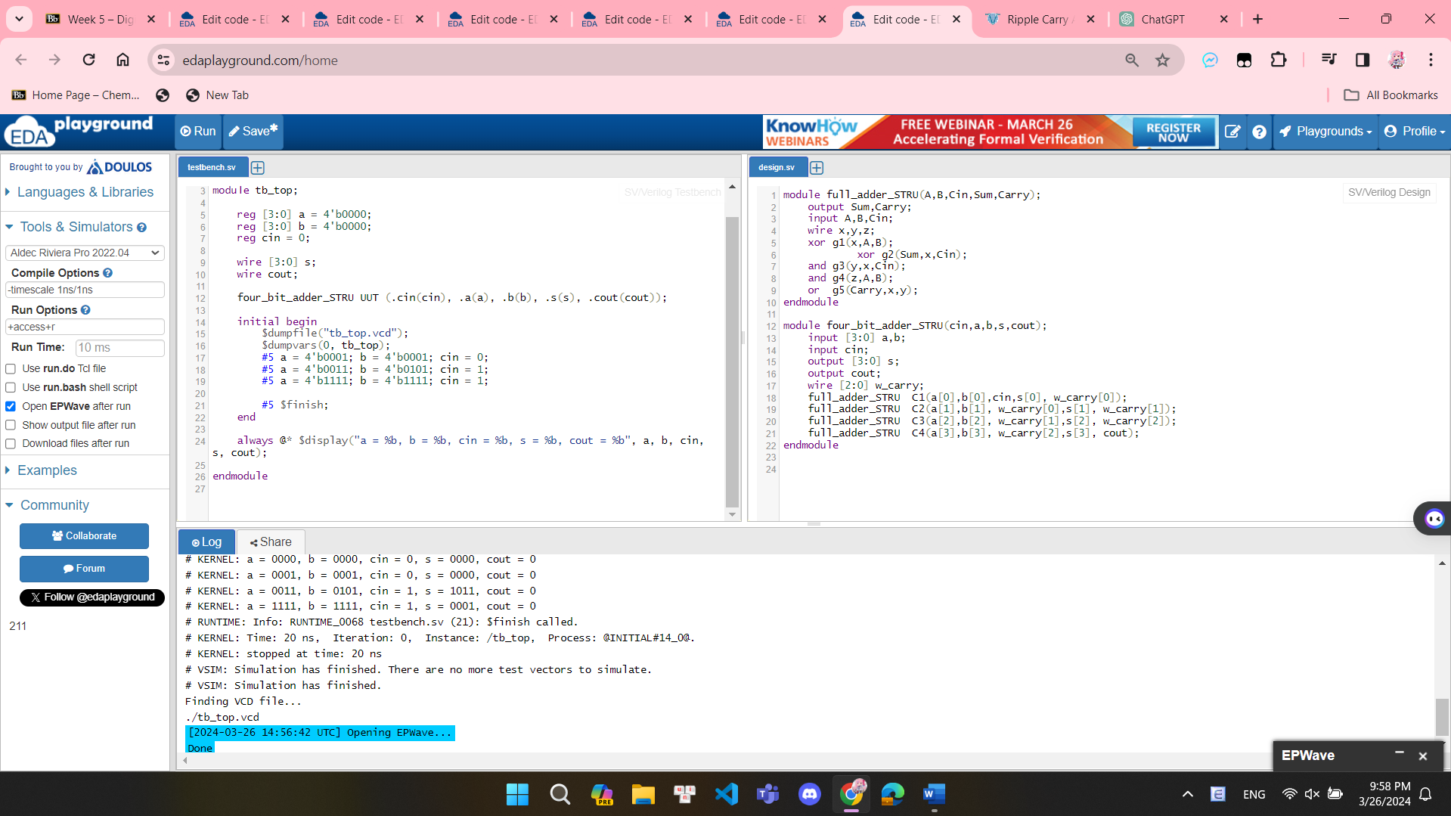

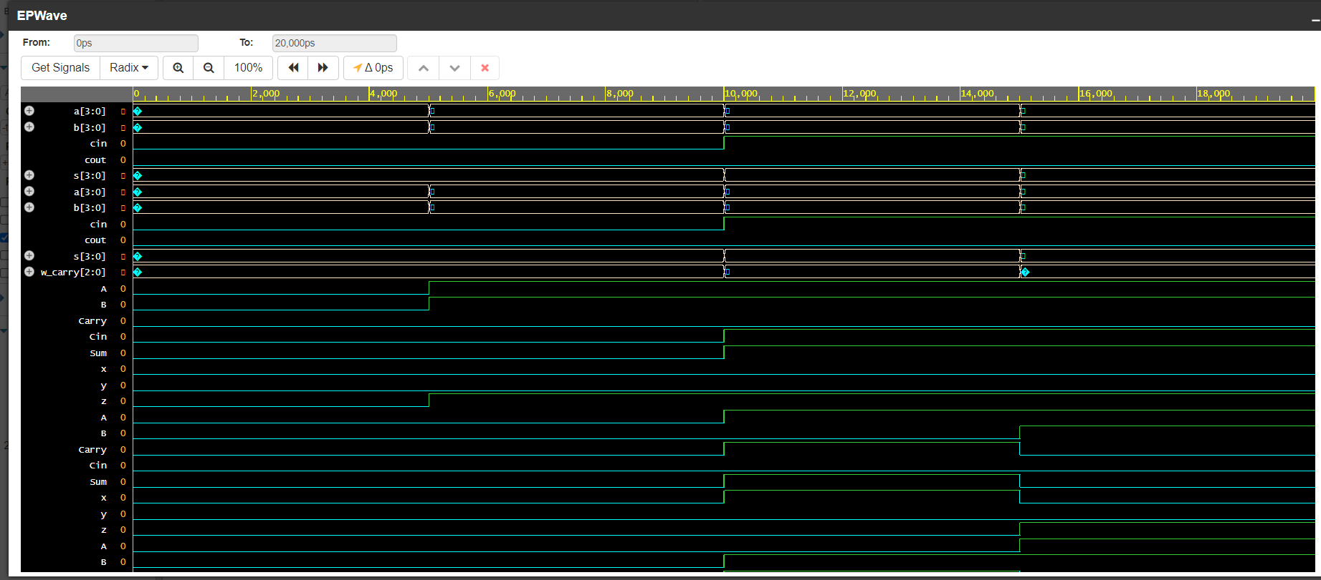

Dataflow model:

module Four_bit_Adder_DF(A,B,Cin,Sum,Cout);

input [3:0] A,B;

input Cin;

output wire [3:0]Sum;

output wire Cout;

wire [4:0]temp;

assign temp=A+B+Cin;

assign Sum=temp[3:0];

assign Cout=temp[4];

endmodule

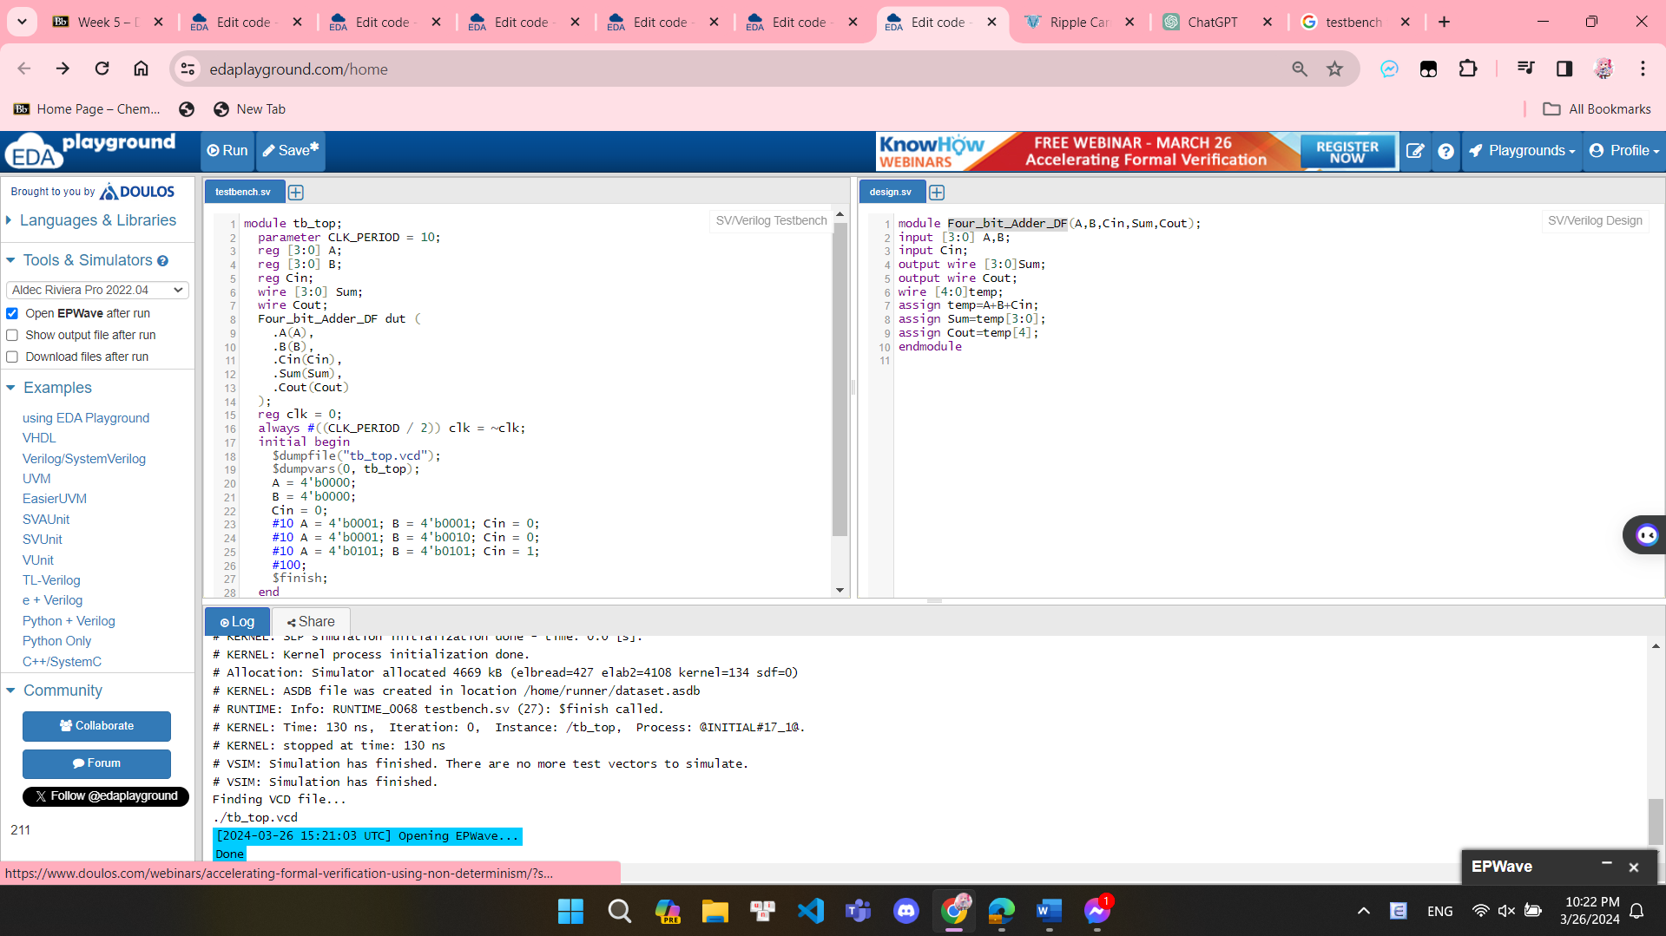

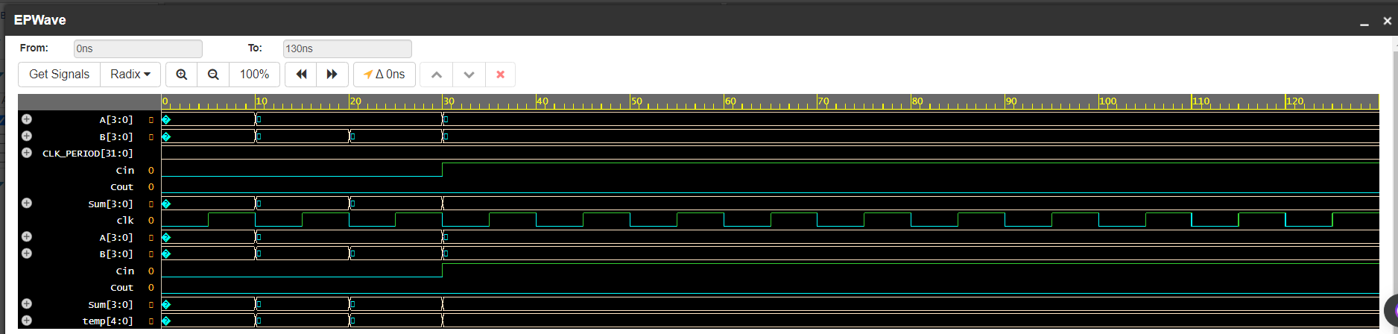

**EXERCISE 5 :WRITE VERILOG TESTBENCH CODES TO SIMULATE 2:1 MULTIPLEXER CIRCUIT:**

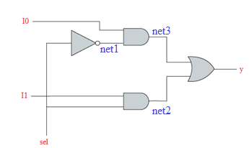 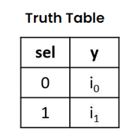

Dataflow model:

module mux21_data_flow(i0,i1,sel,y);

input i0,i1,sel;

output y;

assign y =(i0&(~sel))|(i1&sel);

endmodule

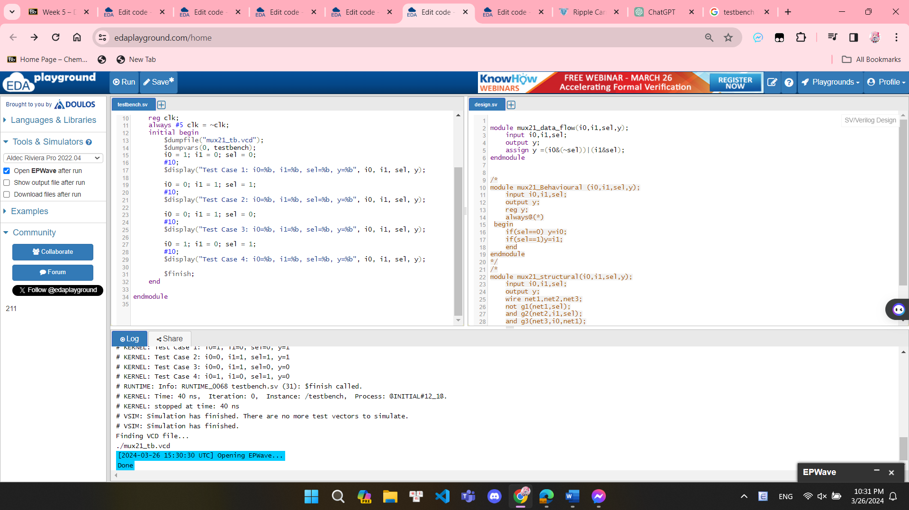

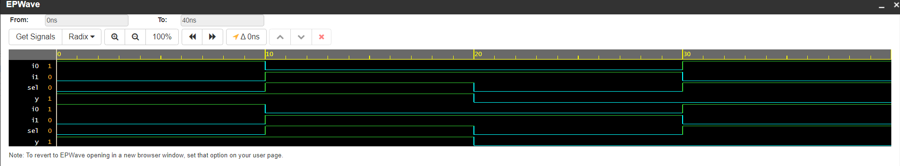

Behavior Model :

module mux21_Behavioural (i0,i1,sel,y);

input i0,i1,sel;

output y;

reg y;

always@(*)

begin

if(sel==0) y=i0;

if(sel==1)y=i1;

end

endmodule

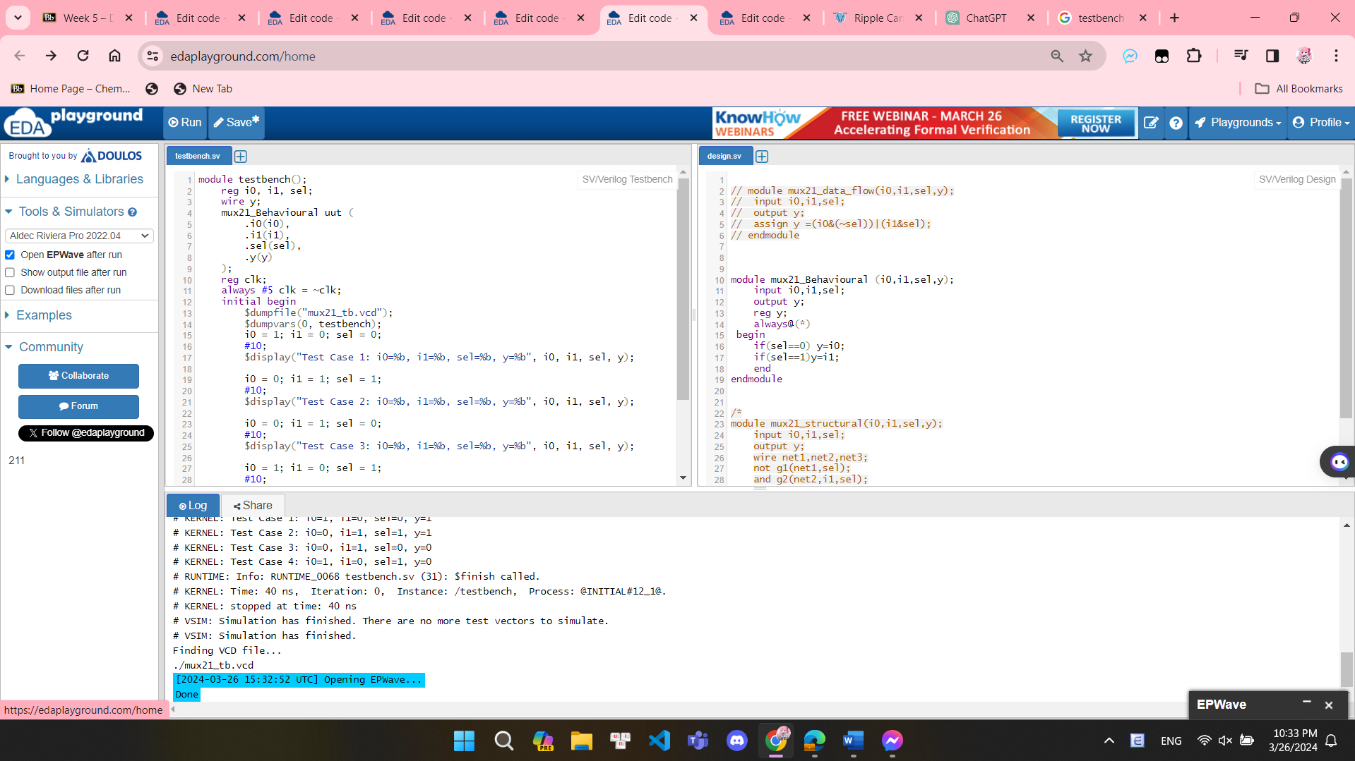

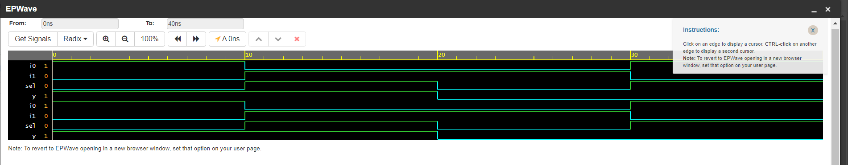

Structural Model:

module mux21_structural(i0,i1,sel,y);

input i0,i1,sel;

output y;

wire net1,net2,net3;

not g1(net1,sel);

and g2(net2,i1,sel);

and g3(net3,i0,net1);

or g4(y,net3,net2);

endmodule

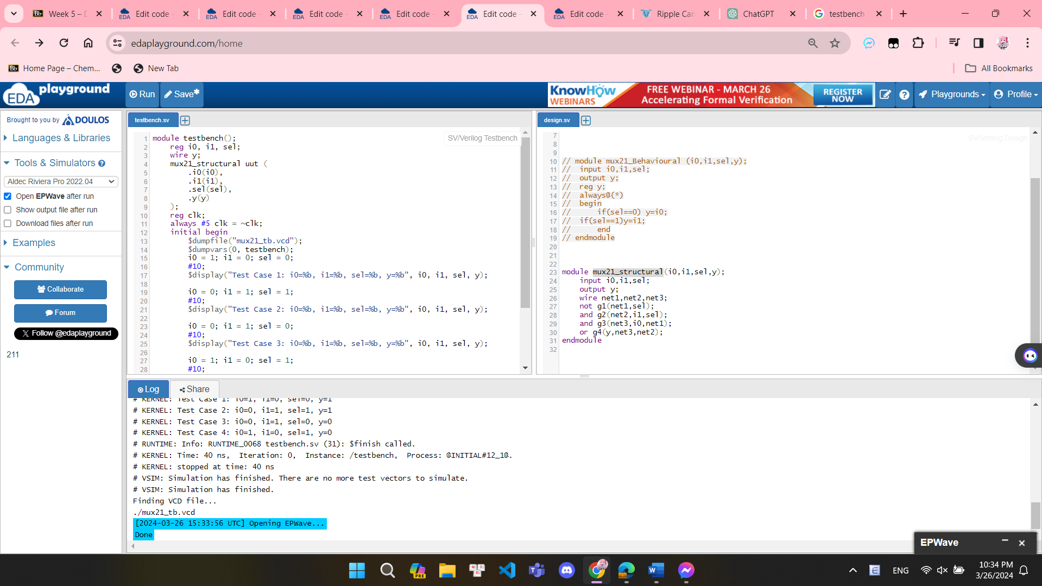

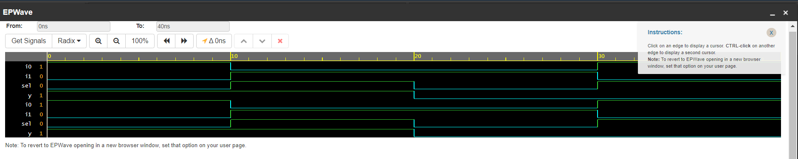

**EXERCISE 6: WRITE VERILOG TESTBENCH CODES TO SIMULATE 4:1 MULTIPLEXER CIRCUIT:**

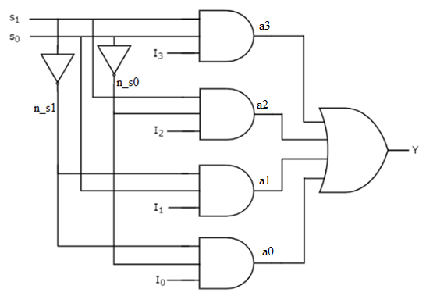 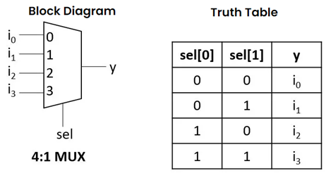

Structural Model:

module mux41_strutural (i0,i1,i2,i3,s0,s1,y);

input i0,i1,i2,i3,s0,s1;

output y;

wire n_s0,n_s1, a0,a1,a2,a3;

not g0(n_s0,s0);

not g1(n_s1,s1);

and g2(a0,i0,n_s0,n_s1);

and g3(a1,i1,n_s1,s0);

and g4(a2,i2,s1,n_s0);

and g5(a3,i3,s1,s0);

or g6(y,a0,a1,a2,a3);

endmodule

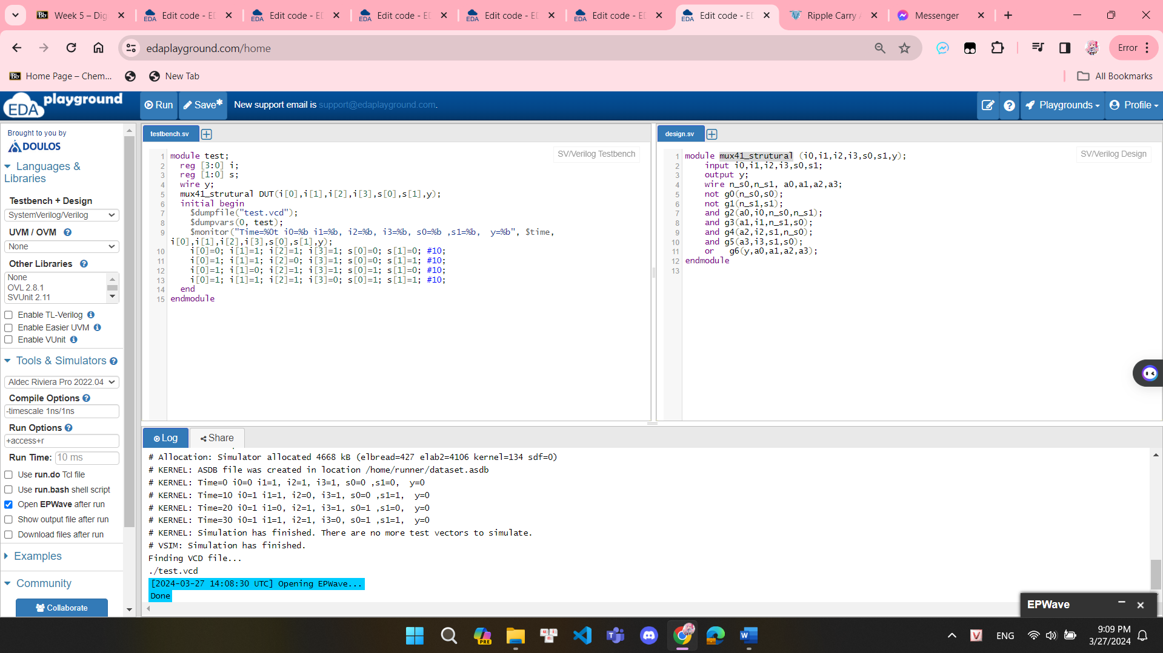

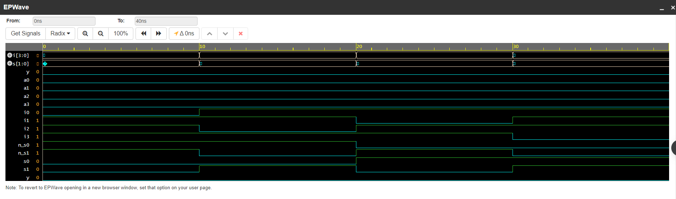

Dataflow model:

module mux41_df (i0,i1,i2,i3,s0,s1,y);

input i0,i1,i2,i3,s0,s1;

output y;

assign y= i0&(~s1)&(~s0) | i1 &(~s1)&s0 | i2&s1&(~s0) | i3&s1&s0;

endmodule

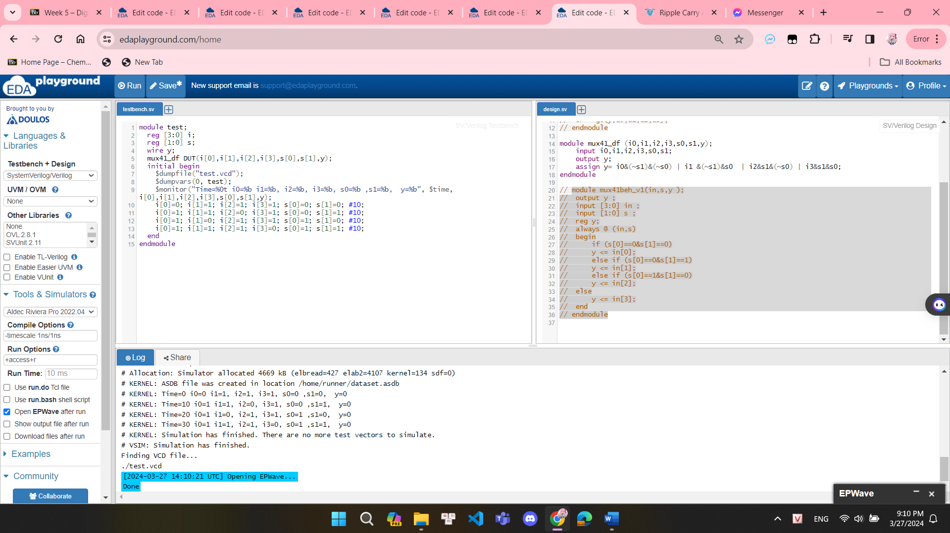

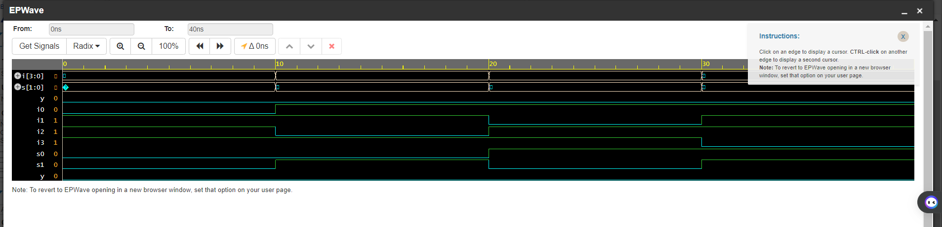

module mux41beh_v1(in,s,y );

output y ;

input [3:0] in ;

input [1:0] s ;

reg y;

always @ (in,s)

begin

if (s[0]==0&s[1]==0)

y <= in[0];

else if (s[0]==0&s[1]==1)

y <= in[1];

else if (s[0]==1&s[1]==0)

y <= in[2];

else

y <= in[3];

end

endmodule

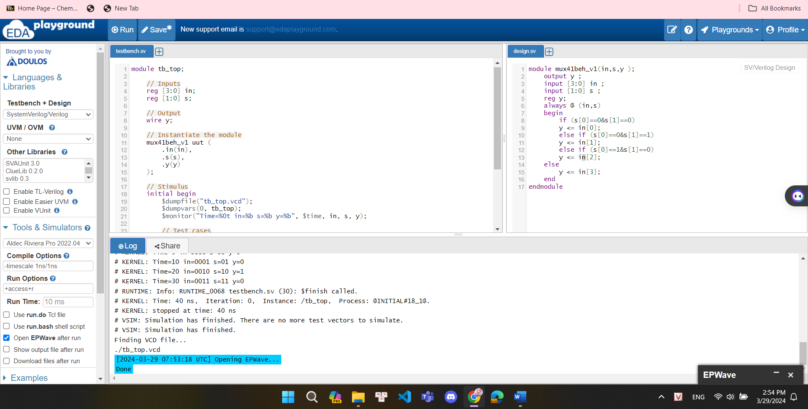

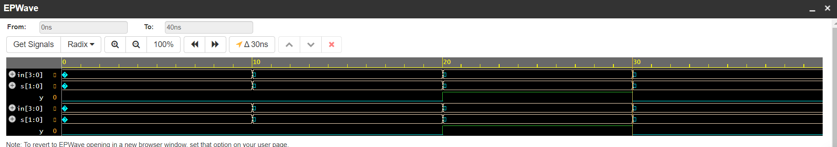

Behavior Model :

module mux41beh_v2(in,s,y );

output y ;

input [3:0]in ;

input [1:0]s ;

reg y;

always@(in,s)

begin

case ({s[1],s[0]})

2'b00: y <= in[0];

2'b01: y <= in[1];

2'b10: y <= in[2];

2'b11: y <= in[3];

endcase

end

endmodule

